**Assignment 1**

**1.Use programming elements to store, load and clear data**

Write a program to calculate factorial of a number.

Example: 5! = 5*4*3*2*1.

**Input:**

Initialize/receive an integer value

**Output:**

Factorial of a given number is 120.

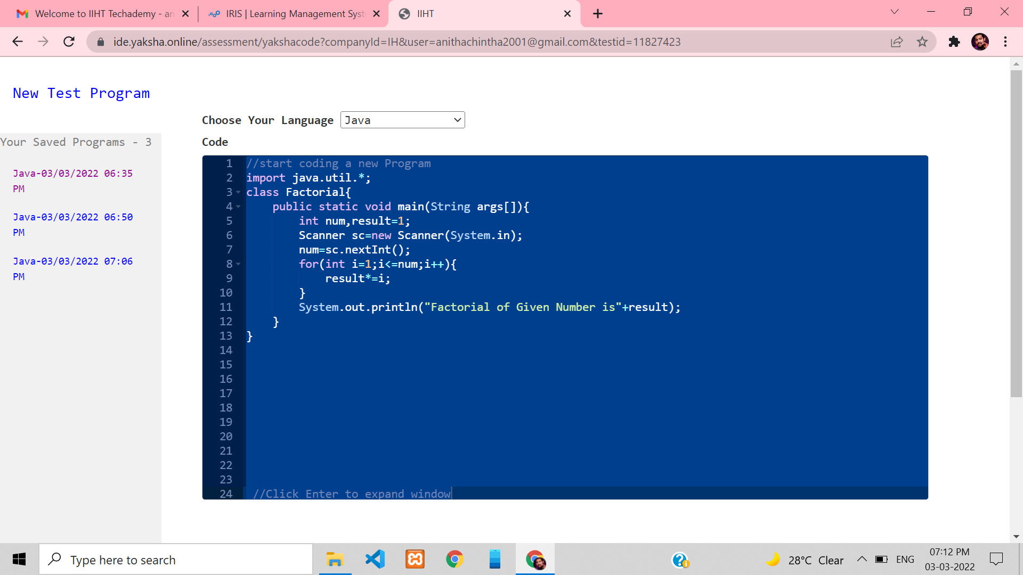

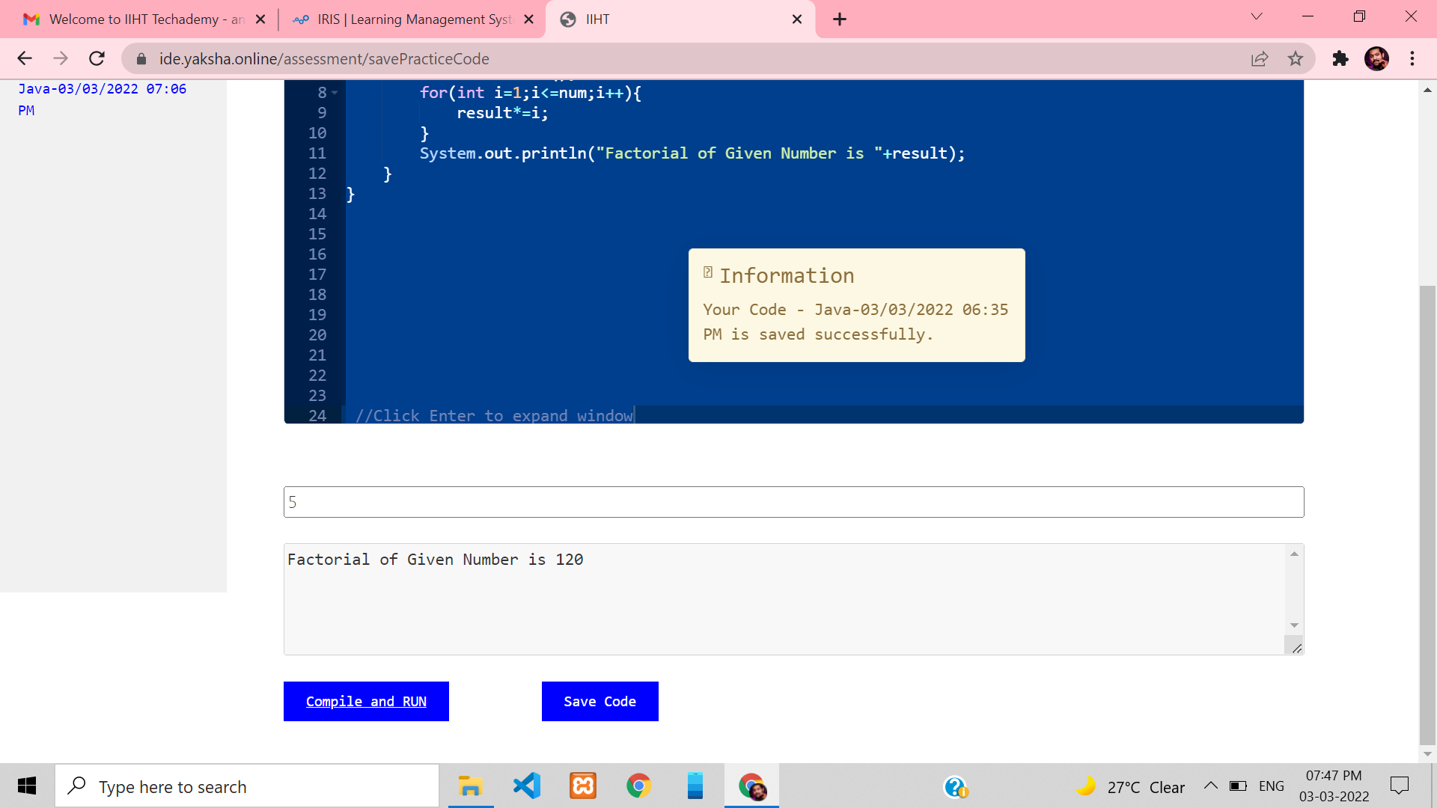

**2.Use programming elements to store, load and clear data**

Write a program that accepts an integer as input and prints the table of that integer up to 12. For example, is the user enters 7, the output should be:

7 x 1 = 7

7 x 2 = 14

.....

7 x 12 = 84

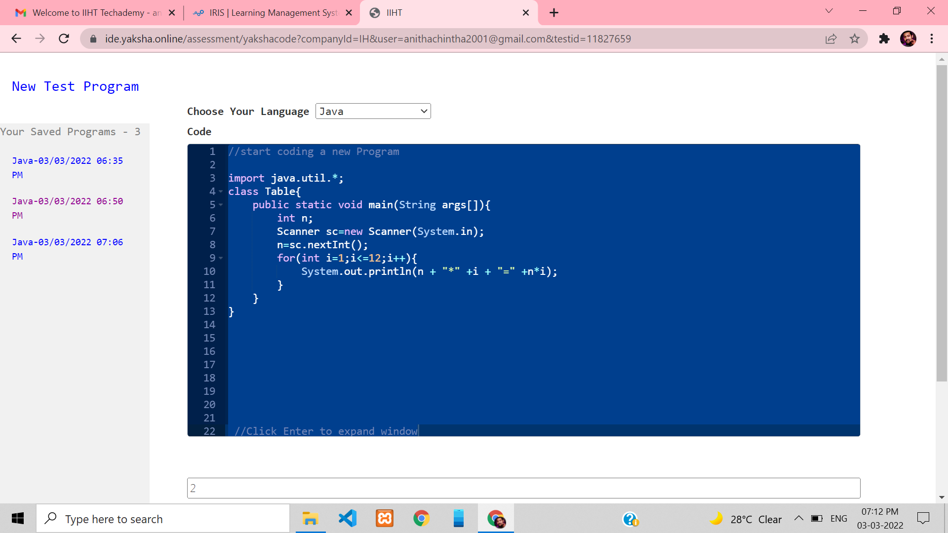

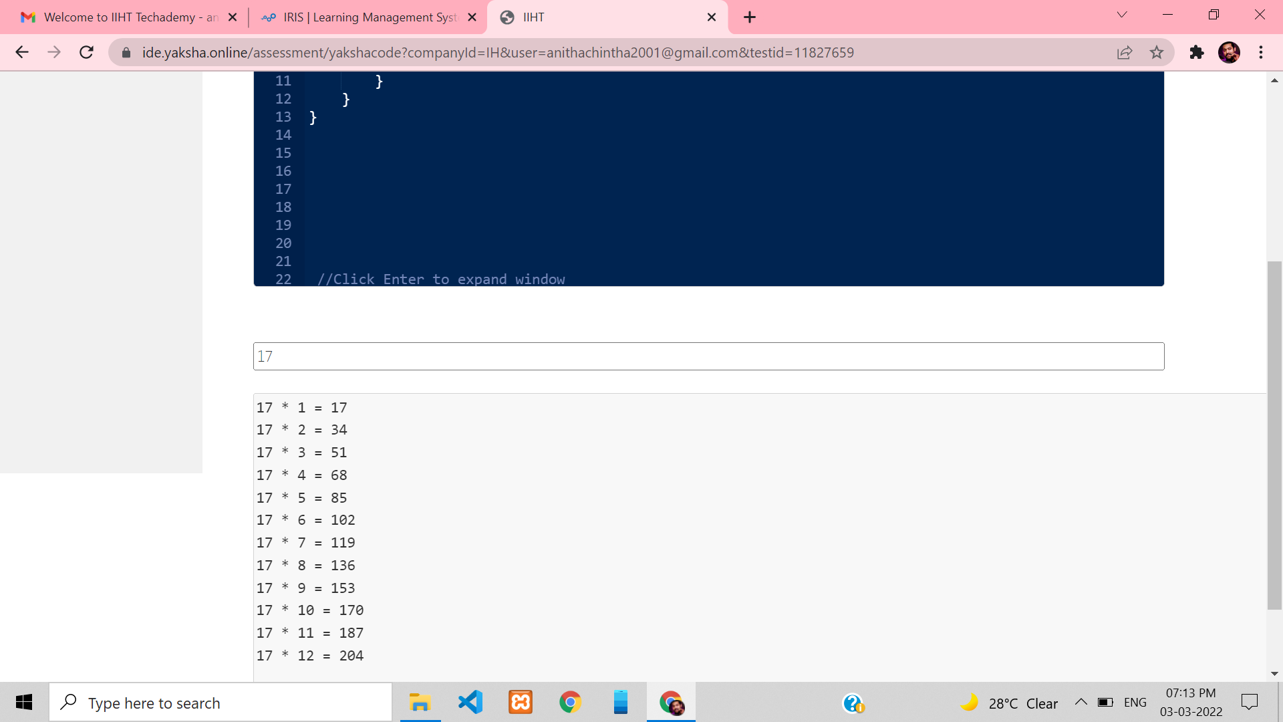

**3.Use programming elements to store, load and clear data**

Write a program that reads in a number from the user and then displays the Hailstone sequence for that number. The problem can be expressed as follows:

• Pick some positive integer and call it n.

• If n is even, divide it by two.

• If n is odd, multiply it by three and add one.

• Continue this process until n is equal to one.

Your program should be able to produce a sample run that looks like this:

**Input is a positive number Output:**

Output is a series of steps showing how it reached the number and then should return total count of steps

